Anjoy Vision (ShenZhen) Information Technology Co.,Ltd.

Product Specification Data Sheet

Model：MC-L12C (Black Light)

Customer ACK | Review | Approval

Update Date | HW Version | Notes
2026/07/17 | V1.0 | Initial Release

Address: Room 610, 6th Floor, Block A, Nanfeng Building, Nanshan Yungu Innovation Industrial Park, No. 4093 Liuxian Road, Pingshan Community, Taoyuan Street, Nanshan District, Shenzhen, Guangdong Province, China

Contact Us

Website: www.anjvision.com

Phone：0755-86568600

- Product Image （Dual-board 38x38）
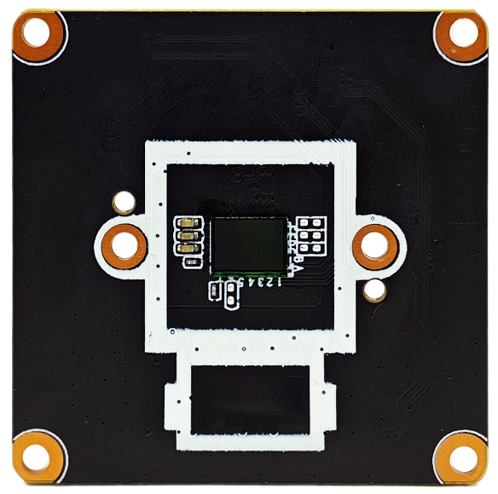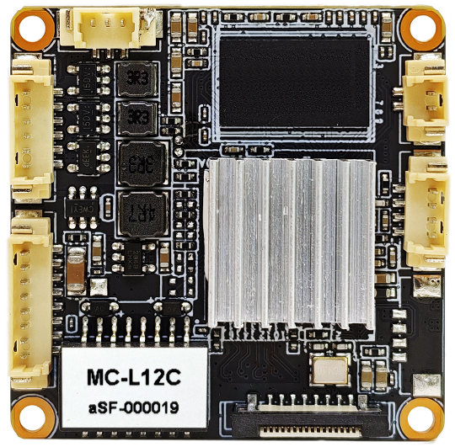
- Key Features
- Processor: Dual-core ARM Cortex-A7 1GHz SoC, 2GB DDR3, 16MB Flash ROM.
- Image Sensor: 1/2.7” 5MP large-format sensor with built-in SoC ISP, delivering exceptional day and night vision performance.
- Video Compression: H.265 video encoding with adjustable multi-resolution frame rates and dynamic bitrate control, reducing network transmission and storage requirements by half.
- Image Optimization: Supports electronic shutter, automatic day/night switching, auto white balance, backlight compensation (BLC), highlight compensation (HLC), and face overexposure prevention.
- Advanced Image Processing: Supports Wide Dynamic Range (HWDR/DWDR), 2D/3D Digital Noise Reduction (DNR), image mirroring/flipping, image cropping, and anti-flicker.
- OSD & Privacy: Supports multi-line OSD text overlay, custom titles, and privacy mask settings.
- IR-CUT & Lighting: Supports multiple day/night control modes and lighting control modes.
- Smart Detection: Supports intelligent alarm functions with precise detection of human figures, vehicles, and non-motorized vehicles, as well as face detection and capture.
- Event Linkage: Supports event-triggered actions including snapshot/recording, audio-visual alarms, mobile push notifications, relay output, FTP upload, and Email alerts.
- False Alarm Filtering: Supports filtering of stationary targets to prevent false alarms, customizable arming schedules, and custom alarm audio upload.
- Remote Access: Supports remote live view and playback via mobile app or PC at any time, with two-way audio intercom functionality.
- Cloud Storage: Supports cloud storage services with encrypted data transmission and storage, ensuring evidence security even if the device is damaged.
- Browser Compatibility: Supports plugin-free HTML5 access across multiple browsers, with excellent compatibility across Windows, Linux, and Mac operating systems.
- PTZ & Lens Control: Supports PTZ control and motorized lens control, with transparent pass-through for various Pelco commands (cruising, tracking, reset, lens learning, etc.).
- Protocol: Supports ONVIF protocols, ensuring compatibility with most third-party NVRs and management platforms on the market.
- Network Protocols: HTTP(s), RTSP, RTMP, FTP, SMTP, DHCP, NTP, DST, P2P, Hik, NFS (Network Storage), etc.
- USB Host Expansion: Supports USB Host peripherals (USB WiFi adapters, USB storage devices, etc.).
- FPC Expansion: Supports a 16-Pin FPC full-function tail board extension (Micro-SD card slot, Reset button, speaker output, amplifier enable, alarm input, relay output).

3. Technical Specifications

Model | MC-L12C
System Architecture | Embedded Linux, ARM 1GHz SoC, 2GB DDR3, 16MB Flash ROM
Image Sensor | 1/2.7” 5MP CMOS
Compression Standard | H.264 / H.265 / H.265+
Shutter Speed | Auto, 1/10s – 1/10,000s
Digital Noise Reduction | Supports 2D/3D DNR
Wide Dynamic Range | Supports HWDR/DWDR, >100dB
Encoding Mode | H.264 / H.265 / H.265+
Bitrates | Adjustable from 512 Kbps to 8 Mbps,VBR/CBR
Main Stream | 30fps @ 5MP (2592x1944) / (2880x1620) / 4MP (2560x1440) / (1920x1920) / 3MP (2304x1296) / (1200x1200) / 1080P / 720P; 60fps@1080P
Sub Stream | 30fps @ 704x576 (D1) / 640x480 (VGA) / 640x360 (360P) / 352x288 (CIF)
Audio Encoding | Supports G.711U, G.711A, AAC; supports noise reduction and echo cancellation
Audio Interface | 1-channel Input / 1-channel Output
Photosensitive Mode | Image-sensor photosensitive / CDS photosensitive
Lighting Mode | 2-channel PWM output; supports Auto / Dual-light / IR / Full-color modes
OSD Overlay | Supports channel name, date/time, custom titles, and multi-line OSD overlay
Privacy Mask | Supports up to 4 areas
Smart Detection | Motion detection, human detection, vehicle detection, non-motorized vehicle detection (with static target filtering), face detection
Alarm Linkage | Supports arming linkage for audio-visual alarms, snapshot/recording, mobile push notifications, alarm output, border flashing, FTP and Email;  Supports custom alarm audio upload
PTZ / Lens Control | Supports motorized lens control and PTZ control;  supports transparent pass-through of preset commands
Reset Function | Supports hardware reset and software reset
Alarm Interface | 1-channel Input / 1-channel Relay Output (requires K10 extend board)
IR-CUT | Supports 1-channel IR-CUT port (typical value: 12V 40-60Ω)
Network Protocols | HTTP(s)/RTSP/RTMP/FTP/SMTP/DHCP/NTP/ DST/P2P/Hik/NFS
ONVIF Compatible | Yes, compatible with most of the third-part NVR
Multi-Browser Support | Compatible with Firefox, Chrome, Edge, Safari, 360 Browser, etc.  (Windows / Linux / Mac)
P2P Cloud Service | Supports mobile remote P2P access and cloud storage
Network Port | 1x RJ-45, 10/100Mbps auto-negotiation
Expansion Features | Supports USB Host expansion (USB WiFi adapter, USB storage, etc.);  Supports 16-pin FPC full-function board expansion;(K10: Micro-SD card slot, Reset button, speaker output, amplifier enable, alarm input, relay output)
Operating Conditions | Power Input: 12VDC ±10%; Temperature: -30°C to 60°C; Humidity: 10% to 90% RH

4. Pin-out Definitions
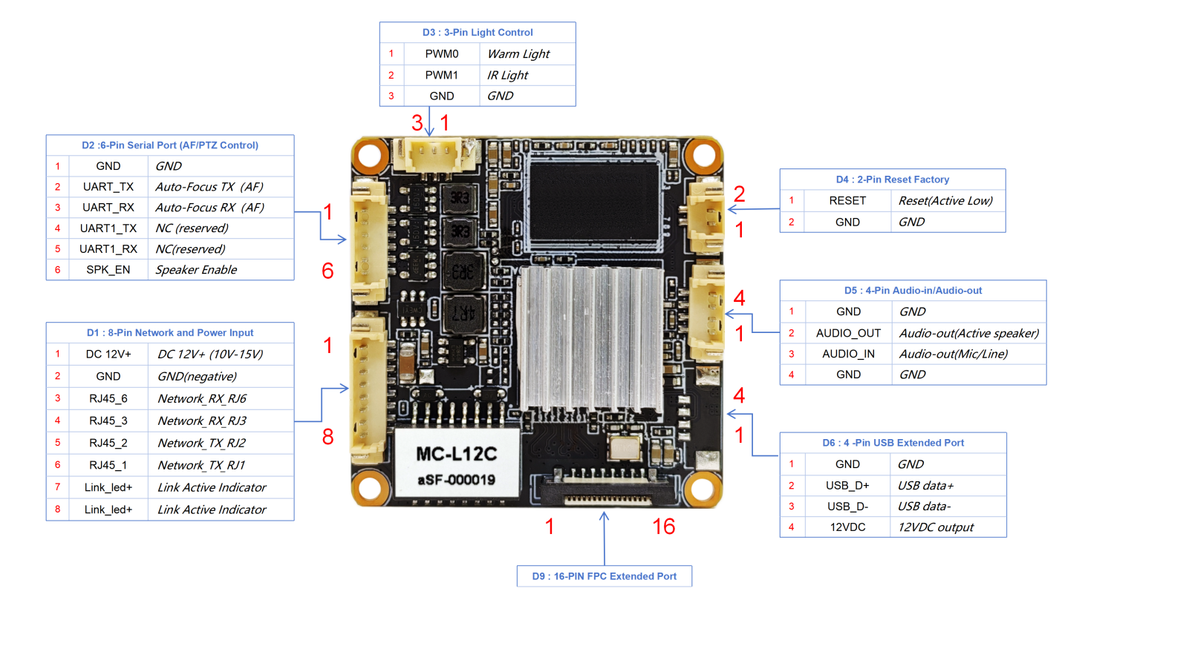
Figure 1 ：Encoding Board
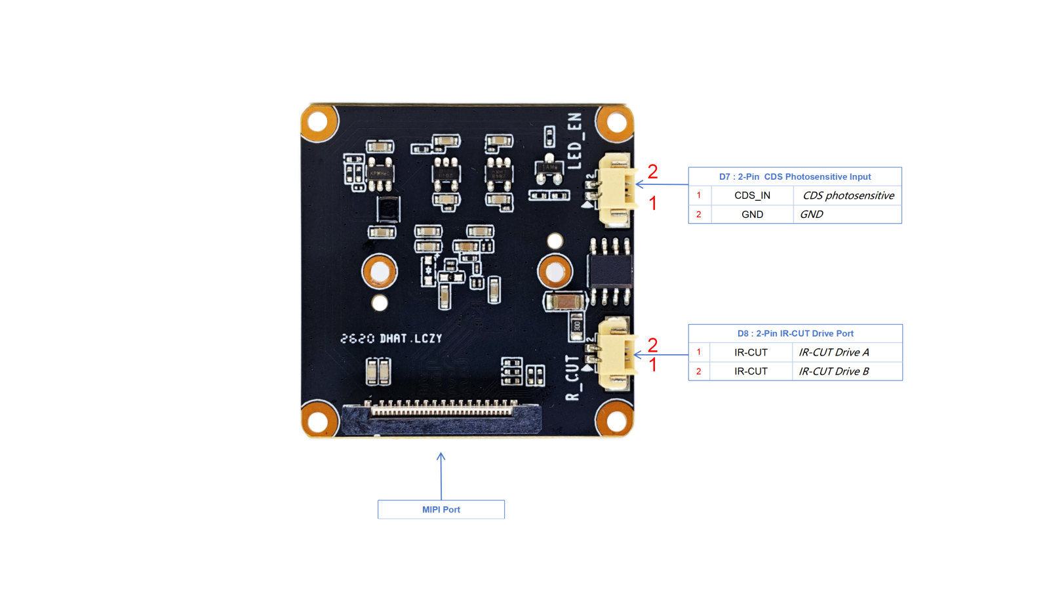
Figure 2 ：Image-sensor Board
Notes：
1. The large red numbers near the inner side of the main board indicate the pin sequence; the detailed pin definitions are listed in the tables above.
2. The USB interface outputs 12VDC by default. Please use our proprietary expansion board or implement your own power conversion to supply peripherals.
Tag | Port Functions | Pin | Pin Definitions | Description
D1 | 8-Pin Network and Power Input | 1 | DC 12V+ | DC 12V+ (10V-15V)
D1 | 8-Pin Network and Power Input | 2 | GND | GND(negative)
D1 | 8-Pin Network and Power Input | 3 | RJ45_6 | Network_RX_RJ6
D1 | 8-Pin Network and Power Input | 4 | RJ45_3 | Network_RX_RJ3
D1 | 8-Pin Network and Power Input | 5 | RJ45_2 | Network_TX_RJ2
D1 | 8-Pin Network and Power Input | 6 | RJ45_1 | Network_TX_RJ1
D1 | 8-Pin Network and Power Input | 7 | Link_led+ | Link Indicator
D1 | 8-Pin Network and Power Input | 8 | Link_led+ | Active Indicator
D2 | 6-Pin Serial Port  (AF/PTZ Control) | 1 | GND | GND
D2 | 6-Pin Serial Port  (AF/PTZ Control) | 2 | UART_TX | Auto-Focus TX（AF）
D2 | 6-Pin Serial Port  (AF/PTZ Control) | 3 | UART_RX | Auto-Focus RX（AF）
D2 | 6-Pin Serial Port  (AF/PTZ Control) | 4 | UART1_TX | NC (reserved)
D2 | 6-Pin Serial Port  (AF/PTZ Control) | 5 | UART1_RX | NC(reserved)
D2 | 6-Pin Serial Port  (AF/PTZ Control) | 6 | SPK_EN | Speaker Enable
D3 | 3-Pin Light Control | 1 | PWM0 | Warm Light
D3 | 3-Pin Light Control | 2 | PWM1 | IR Light
D3 | 3-Pin Light Control | 3 | GND | GND
D4 | 2-Pin Reset Factory | 1 | RESET | Reset(Active Low) hold 5s
D4 | 2-Pin Reset Factory | 2 | GND | GND
D5 | 4-Pin Audio-in/Audio-out | 1 | GND | GND
D5 | 4-Pin Audio-in/Audio-out | 2 | AUDIO_OUT | Audio-out(Active speaker)
D5 | 4-Pin Audio-in/Audio-out | 3 | AUDIO_IN | Audio-out(Mic/Line)
D5 | 4-Pin Audio-in/Audio-out | 4 | GND | GND
D6 | 4-Pin USB Extended Port | 1 | GND | GND
D6 | 4-Pin USB Extended Port | 2 | USB_D+ | USB data+
D6 | 4-Pin USB Extended Port | 3 | USB_D- | USB data-
D6 | 4-Pin USB Extended Port | 4 | 12V | 12VDC output
D7 | 2-Pin CDS Photosensitive Input | 1 | CDS_IN | CDS photosensitive
D7 | 2-Pin CDS Photosensitive Input | 2 | GND | GND
D8 | 2-Pin IR-CUT Drive Port | 1 | IR-CUT | IR-CUT Drive A
D8 | 2-Pin IR-CUT Drive Port | 2 | IR-CUT | IR-CUT Drive B
D9 | 16-Pin FPC  Expansion Port | 1 | IO_OUT
D9 | 16-Pin FPC  Expansion Port | 2 | IO_INPUT
D9 | 16-Pin FPC  Expansion Port | 3 | SD_CD
D9 | 16-Pin FPC  Expansion Port | 4 | SD_D1
D9 | 16-Pin FPC  Expansion Port | 5 | SD_D0
D9 | 16-Pin FPC  Expansion Port | 6 | GND
D9 | 16-Pin FPC  Expansion Port | 7 | SD_CLK
D9 | 16-Pin FPC  Expansion Port | 8 | GND
D9 | 16-Pin FPC  Expansion Port | 9 | SD_CMD
D9 | 16-Pin FPC  Expansion Port | 10 | SD_D3
D9 | 16-Pin FPC  Expansion Port | 11 | SD_D2
D9 | 16-Pin FPC  Expansion Port | 12 | VDD
D9 | 16-Pin FPC  Expansion Port | 13 | KEY_RST
D9 | 16-Pin FPC  Expansion Port | 14 | 3.3VDC
D9 | 16-Pin FPC  Expansion Port | 15 | 3.3VDC
D9 | 16-Pin FPC  Expansion Port | 16 | 3.3VDC

- Optional Expansion Boards

Name | Model | Function Descriptions
Expansion Tail Board | K10 | 16-Pin FPC full-function tail board;(Expands Micro-SD card slot, Reset button, speaker output, amplifier enable, alarm input, relay output)
AF Board | H-AF | Supports 4x / 5x motorized AF lenses on the market
WiFi Board | MT-W3 | 2.4G WiFi6 Bluetooth

Note: Expansion boards require dedicated firmware for support.


WeChat Contact

